**Assignment 10.2:**

Implement the concept given in below blog link and share the complete steps along with

Screenshots.

https://acadgild.com/blog/loading-data-into-hbase-using-pig-scripts/

Dataset:

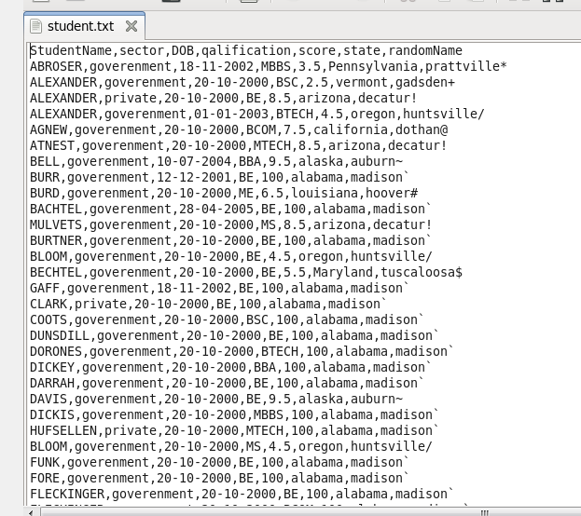

Dataset in Downloads folder:



Copying dataset ‘student.txt’ from local to hdfs:







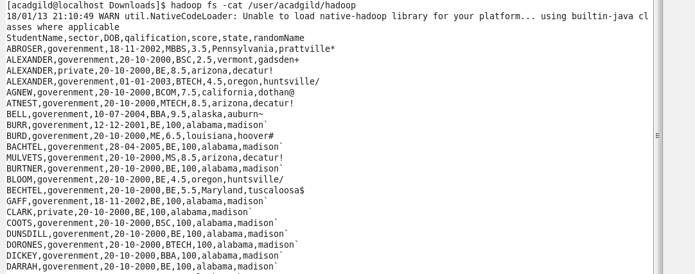

Including jar files of HBase to Pig classpath:



Starting Hbase shell:

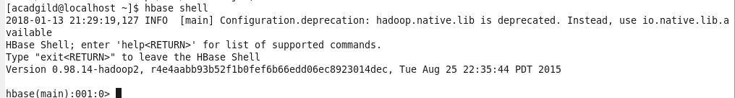

Creating Hbase table ‘studentAcad’

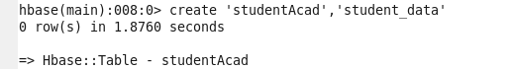

Coming out from HBase by typing exit



Entering in to pig grunt shell:

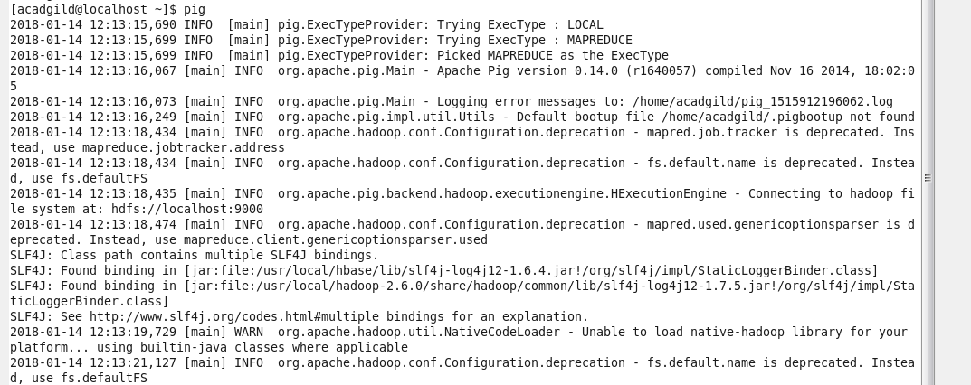

Inside PIG mode, we can load data from HDFS:



Transfer the data inside HBase by STORE command:



Once the success message is displayed as shown below, it is confirmed that our data is loaded inside HBase table:



Result can be displayed through **scan** command followed by table name inside single quotes (‘ ‘):



